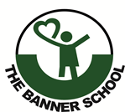
CREATIVE ARTS
Name: _________________________________________________
ATTEMPT ALL THESE QUESTIONS
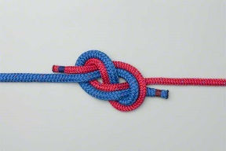

Q1. Macrame is a form of textile making and it is done by using repeated knots.

Some simple and basic knots are:

- ….…………………………………………………………..

- ….………………………………………………………….

Q2. Mention the two (2) methods used in tying Overhand knots.

- ….…………………………………………………………….

- ….……………………………………………………………

Q3. Mention two (2) benefits of tying knots.

- ….…………………………………………………………………

- ….…………………………………………………………………

Reference: https://blog.girlscouts.org/2019/06/10-essential-knots-for-girl-scouts.html
CREATIVE ARTS
Name: _________________________________________________
ATTEMPT ALL QUESTIONS

Q1. Imaginative drawing is a composed or drawing of pictures we have not seen or come across before directly from our mind.

Why do we create imaginative drawing?

….………………………………………………………………………….
….………………………………………………………………………….
….………………………………………………………………………….

Q2. Compose your own imaginative drawing in the box below.

